MONGODB

ACIDS AND INDEXES:

ATOMICITY:

In MongoDB, atomicity refers to the property of operations being either fully completed or not at all within a single transaction or document update. MongoDB uses the concept of atomic operations at the document level. This means that for operations like updates or inserts on a single document, MongoDB ensures that these operations are atomic. If multiple operations are part of a transaction, MongoDB provides support for multi-document transactions that ensure all operations within the transaction are either committed or rolled back as a whole. This ensures data integrity and consistency, preventing partial updates that could lead to inconsistent states in the database. MongoDB's support for atomic operations and transactions helps maintain the reliability and accuracy of data across complex operations and distributed systems.

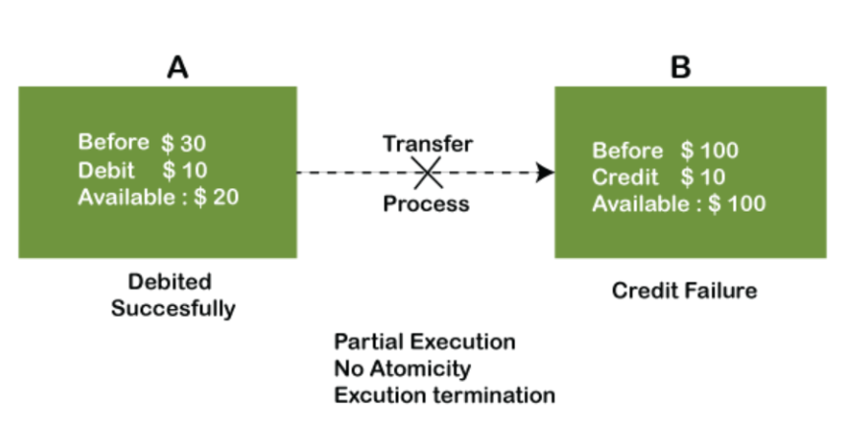

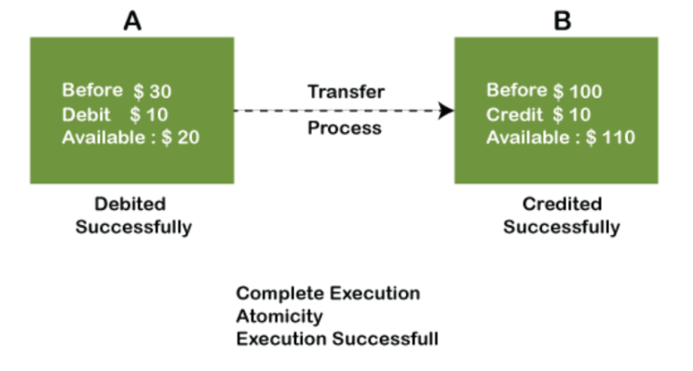

CONSISTENCY:

In MongoDB, consistency refers to the reliability and accuracy of data across the database system. MongoDB ensures consistency by maintaining the state where data remains valid and up-to-date during and after transactions or operations. This is achieved through features like replica sets, where data written to the primary node is replicated to secondary nodes to ensure all reads reflect the most recent writes. MongoDB also supports configurable write concerns to control the level of consistency, allowing developers to choose between strong consistency guarantees or higher availability and performance based on application needs. Overall, MongoDB's consistency mechanisms help maintain data integrity and reliability, crucial for ensuring predictable and dependable application behavior in various deployment scenarios.

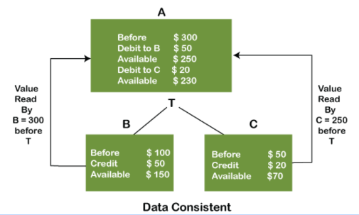

EVENTUAL CONSISTENCY:

Not consistent at that moment but gradually.

EXAMPLE:

If Virat Kohli posts in instagram, It wont be available at that moment to all.

ISOLATION:

In MongoDB, isolation refers to the property that ensures transactions or operations are executed independently of each other, without interference or dependency. MongoDB provides isolation through its transaction model, which allows multiple operations within a transaction to be executed in a way that each transaction is isolated from others until it is committed. This means changes made within one transaction are not visible to other transactions until the transaction commits, ensuring that transactions are executed as if they were the only operations running on the database. MongoDB's support for multi-document transactions further enhances isolation by allowing developers to perform complex operations across multiple documents or collections while ensuring each transaction's changes are isolated until they are finalized. This isolation mechanism helps maintain data integrity and consistency, ensuring reliable and predictable behavior across concurrent transactions in MongoDB databases.

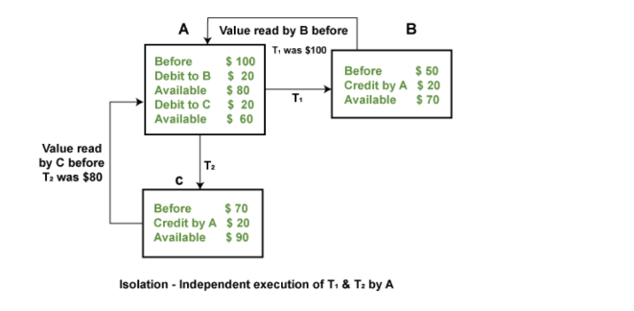

REPLICATION(MASTER-SLAVE):

In MongoDB, replication with master-slave architecture refers to the process where data from a primary node (master) is asynchronously copied to one or more secondary nodes (slaves). The primary node handles all write operations and propagates these changes to the secondary nodes, ensuring data redundancy and fault tolerance. This replication mechanism enhances availability and scalability by allowing secondary nodes to serve read operations independently, thereby distributing the workload. In case of a primary node failure, MongoDB can automatically elect a new primary from the available secondary nodes, maintaining continuous database operations. MongoDB's replication also supports features like delayed replication, where data changes can be applied to secondary nodes with a specified delay, providing protection against data corruption or accidental deletions. Overall, MongoDB's master-slave replication architecture ensures data durability, high availability, and efficient scaling of read operations in distributed database environments.

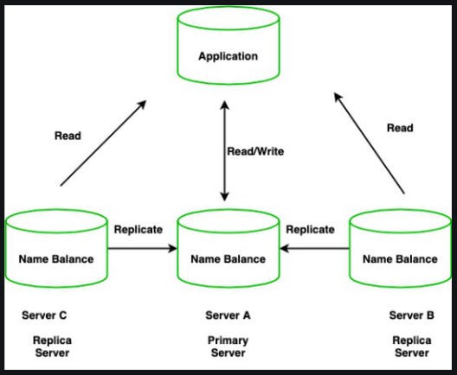

SHARDING:

In MongoDB, sharding is a technique used for horizontal scaling of data across multiple machines or nodes in a distributed database system. It involves partitioning data into smaller chunks called shards, which are distributed across different servers or clusters. Each shard contains a subset of the dataset, allowing MongoDB to manage larger datasets and handle increased throughput by distributing read and write operations across multiple shards. MongoDB uses a sharded cluster architecture where data distribution and balancing are managed by the mongos routers, which direct queries to the appropriate shards based on a shard key. This approach improves performance and scalability, as queries can be executed in parallel across multiple shards, reducing response times and increasing overall system capacity. Sharding in MongoDB also supports automatic data migration and rebalancing, ensuring even distribution of data and efficient utilization of resources as the dataset grows or workload changes.

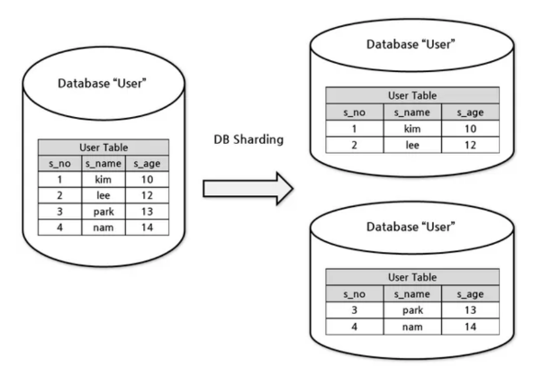

REPLICATION VS SHARDING:

In MongoDB, replication and sharding are two distinct strategies for scaling and managing data in distributed database environments. Replication involves copying data from a primary node to one or more secondary nodes (slaves) to ensure data redundancy, fault tolerance, and high availability. It enhances reliability by allowing secondary nodes to serve read operations independently and enabling automatic failover if the primary node fails. On the other hand, sharding focuses on horizontal scaling by partitioning data into smaller subsets called shards, which are distributed across different servers or clusters. Each shard contains a portion of the dataset, and MongoDB's sharded cluster architecture ensures efficient distribution of read and write operations across shards based on a shard key. While replication ensures data redundancy and availability, sharding enhances scalability and performance by enabling parallel execution of queries across multiple shards. Together, replication and sharding in MongoDB provide robust solutions for managing large-scale data and supporting demanding workloads in distributed database environments.

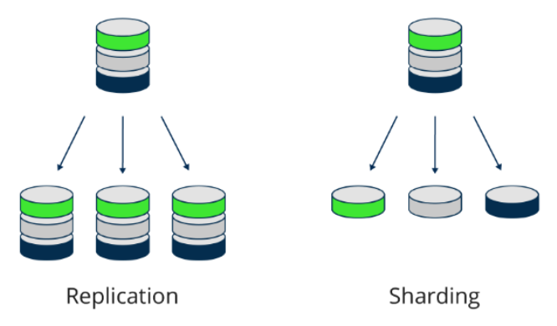

REPLICATION + SHARDING:

In MongoDB, replication and sharding are complementary strategies used together to achieve both high availability and scalability in distributed database systems. Replication involves copying data from a primary node to multiple secondary nodes (slaves), ensuring data redundancy and fault tolerance. This setup enhances reliability by allowing secondary nodes to serve read operations independently and providing automatic failover in case of primary node failure. Sharding, on the other hand, focuses on horizontal scaling by partitioning data into smaller chunks called shards, which are distributed across different servers or clusters based on a shard key. This allows MongoDB to manage large datasets and handle increased throughput by distributing read and write operations across multiple shards. Together, replication and sharding in MongoDB enable systems to achieve both high availability through data redundancy and scalability through distributed data management, ensuring robust performance and reliability for demanding applications.

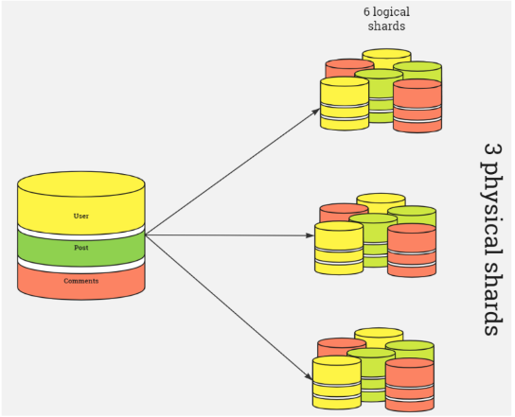

INDEXES:

In MongoDB, indexes are data structures that store a small portion of the collection's data in an easy-to-traverse form. They improve the efficiency of read operations by allowing MongoDB to quickly locate documents based on the indexed fields. MongoDB supports various types of indexes, including single field, compound, multikey, geospatial, text, hashed, and wildcard indexes, each optimized for different query patterns. Indexes can significantly speed up queries by reducing the number of documents MongoDB needs to examine during query execution. However, they also impose overhead on write operations because MongoDB must update indexes whenever documents are added, modified, or removed. Properly designed and maintained indexes are crucial for optimizing performance in MongoDB databases, balancing query speed with the impact on write operations based on the specific workload and access patterns of the application.

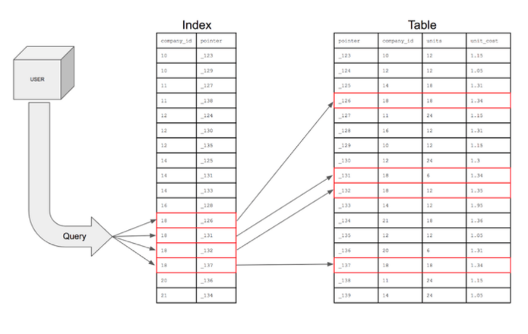TYPES OF INDEXES:

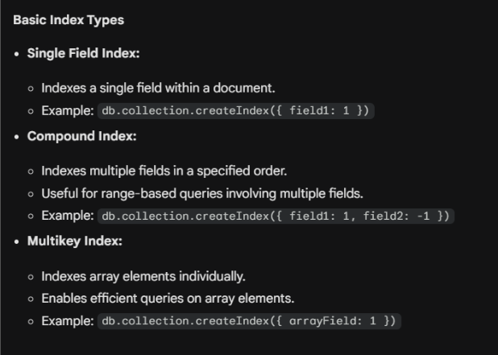

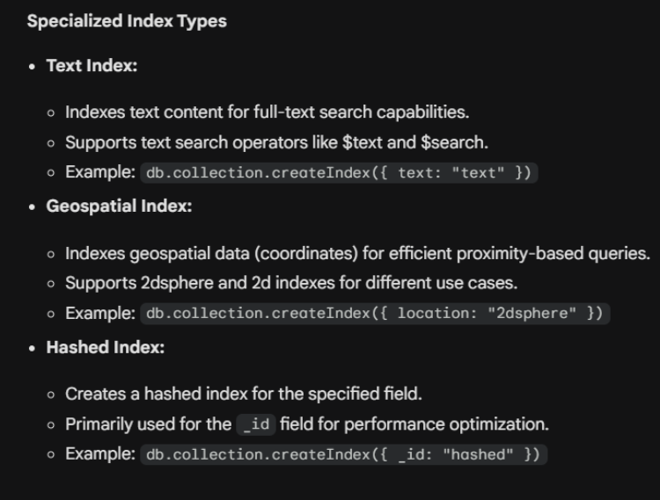



INSERTMANY:

In MongoDB, `insertMany` is a method used to insert multiple documents into a collection in a single operation. This method takes an array of documents as its parameter, where each document represents a JavaScript object containing the data to be inserted. `insertMany` is designed for efficient bulk insertion, which can significantly reduce overhead compared to multiple individual insert operations. It ensures atomicity at the level of a single operation, meaning that either all documents are inserted successfully or none are, maintaining data consistency. Additionally, `insertMany` supports ordered and unordered insertion modes. In ordered mode, MongoDB attempts to insert documents in the order provided, stopping on the first error encountered, while in unordered mode, it continues with remaining documents even after an error. This method is particularly useful for scenarios such as initial data loading, batch processing, or when handling large datasets efficiently in MongoDB.

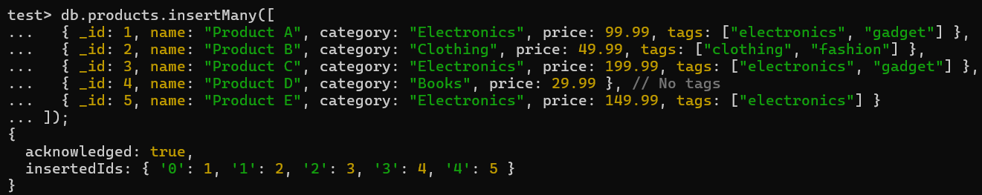

The `insertMany` operation in MongoDB allows for the efficient insertion of multiple documents into a collection in a single command. Each document, represented as a JavaScript object within an array, can contain various fields such as `_id`, `name`, `category`, `price`, and `tags`. Upon execution, MongoDB ensures atomicity of the operation, meaning all documents are inserted or none if an error occurs, ensuring data consistency. The operation returns an acknowledgment when completed (`acknowledged: true`), along with a mapping of the inserted document `_id` values for reference. This method is optimal for scenarios where bulk data insertion is required, such as initial data loading or batch processing, providing a streamlined approach to managing collections in MongoDB.

GETINDEXES:

In MongoDB, `getIndexes` is a method used to retrieve information about the indexes defined on a collection. When called on a specific collection, `getIndexes` returns a list of documents, each representing an index within that collection. These documents contain details such as the index name, key patterns specifying the fields indexed, index options like unique constraints or TTL (Time-To-Live) settings, and any additional metadata related to the index. This method is particularly useful for administrators and developers to inspect and understand the indexing strategies applied to their collections, helping optimize query performance, enforce data integrity, and manage data expiration policies effectively.

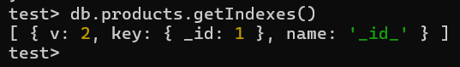

When executing `db.products.getIndexes()` in MongoDB's shell, the returned array represents the current indexes defined on the `products` collection. Each document within the array provides detailed information about an index, including its version (`v`), key pattern (`key`) specifying the indexed fields, and the `name` of the index. In the example given, the output indicates a default index on the `_id` field (`{ _id: 1 }`) with a name of `_id_`. This index is automatically created by MongoDB for the `_id` field, ensuring efficient retrieval and uniqueness of documents by their primary key. Understanding and managing indexes through methods like `getIndexes()` is crucial for optimizing query performance and ensuring database efficiency in MongoDB deployments.

CREATEINDEX(UNIQUE INDEX):

In MongoDB, creating a unique index using the `createIndex` method ensures that the indexed field or fields contain unique values across all documents in the collection. When specifying `{ unique: true }` as an option during index creation, MongoDB enforces this uniqueness constraint, preventing documents from having duplicate values for the indexed field(s). Unique indexes are useful for fields that must contain distinct values, such as usernames or email addresses, ensuring data integrity and supporting efficient query operations. If an attempt is made to insert or update a document with a value that already exists in the unique index, MongoDB will reject the operation and return a duplicate key error. This feature helps maintain consistent and accurate data within the collection, making unique indexes a fundamental tool for managing and querying MongoDB databases effectively.

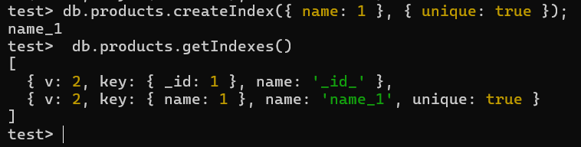

When executing `db.products.createIndex({ name: 1 }, { unique: true })` in MongoDB, a new index is created on the `name` field of the `products` collection. The `{ name: 1 }` indicates that the index is ascending (`1`), meaning it will store values in alphabetical order for efficient query retrieval. The `{ unique: true }` option ensures that the `name` field values must be unique across all documents in the collection, preventing duplicate entries for this field. After creating the index, calling `db.products.getIndexes()` returns an array detailing all indexes on the `products` collection. In this case, besides the default `_id` index, there is now a new index named `name_1` with the `name` field as its key and uniqueness enforced. This index configuration enhances query performance for operations that involve searching or sorting by the `name` field, while maintaining data integrity by enforcing uniqueness constraints. Efficient use of indexes is crucial for optimizing database performance and supporting data management operations in MongoDB.

CREATEINDEX(SPARSE INDEX):

In MongoDB, creating a sparse index using the `createIndex` method allows for indexing only documents that contain the indexed field(s), omitting documents that do not have the indexed field(s). When specifying `{ sparse: true }` as an option during index creation, MongoDB ensures that the index only includes documents where the indexed field(s) exist. This is particularly useful when indexing fields that are not present in all documents, reducing index size and improving query performance by excluding unnecessary documents from index scans. Sparse indexes are commonly used for fields that are optional or not consistently present across all documents, such as additional attributes or optional properties. They help optimize storage and query performance by focusing index resources on relevant data, while still supporting efficient retrieval of indexed documents when the indexed fields are present.

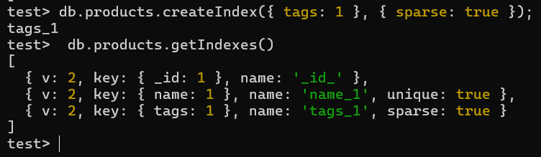

When `db.products.createIndex({ tags: 1 }, { sparse: true })` is executed in MongoDB, a sparse index is created on the `tags` field of the `products` collection. The `{ tags: 1 }` specifies an ascending index (`1`), which sorts the values of `tags` in alphabetical order for efficient querying. The `{ sparse: true }` option indicates that MongoDB will only index documents where the `tags` field exists, omitting documents that do not have a `tags` field altogether. After creation, `db.products.getIndexes()` shows all indexes on the `products` collection, including the default `_id` index and now the `tags_1` index. This sparse index configuration optimizes storage and query performance by indexing only relevant documents with the `tags` field, avoiding unnecessary index entries for documents without `tags`. Sparse indexes are beneficial for fields that are optional or not uniformly present across all documents, supporting efficient data retrieval while conserving index resources in MongoDB deployments.

CREATEINDEX(COMPOUND INDEX):

In MongoDB, creating a compound index using the `createIndex` method allows for indexing multiple fields together in a single index entry. This type of index is defined by specifying a key pattern that includes more than one field, such as `{ field1: 1, field2: -1 }`, where `1` indicates ascending order and `-1` indicates descending order for each respective field. Compound indexes support queries that involve conditions on multiple fields, enabling efficient retrieval of documents based on combined criteria. When created, MongoDB stores documents in the index sorted by the specified fields, facilitating rapid query execution by minimizing the number of documents that need to be scanned. This indexing strategy is particularly useful for optimizing queries that frequently filter or sort data based on multiple attributes. Properly designed compound indexes can significantly enhance query performance and support complex data retrieval operations in MongoDB databases.

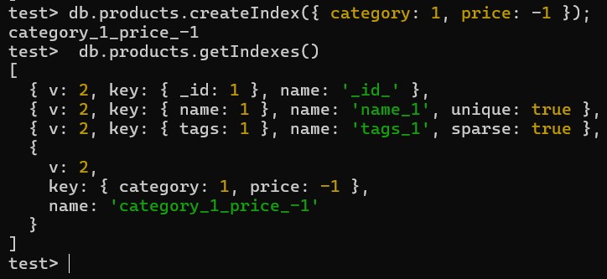

When `db.products.createIndex({ category: 1, price: -1 })` is executed in MongoDB, a compound index is created on the `category` and `price` fields of the `products` collection. The `{ category: 1, price: -1 }` key pattern specifies that `category` is indexed in ascending order (`1`), while `price` is indexed in descending order (`-1`). This compound index allows MongoDB to efficiently query and sort documents based on both `category` and `price` criteria together. The created index, named `category_1_price_-1`, organizes documents in storage to facilitate rapid retrieval and sorting of data by these fields, optimizing query performance for operations that involve filtering or sorting by category and price simultaneously. Using compound indexes is advantageous in scenarios where queries frequently combine multiple fields for data retrieval, enabling MongoDB to leverage index efficiency and speed up complex query operations in database applications.

CREATEINDEX(MULTIKEY INDEX):

In MongoDB, a multikey index is created using the `createIndex` method to index fields that contain arrays. When you specify a field that contains an array, MongoDB creates separate index entries for each element in the array across all documents in the collection. This allows efficient querying and sorting based on individual elements within the array. For example, if a collection `products` has a field `tags` that contains arrays of tags for each product, creating a multikey index on `{ tags: 1 }` will index each tag separately. This indexing strategy supports queries that filter or sort based on specific elements within the arrays, improving query performance for applications that work with nested or multi-valued data structures. Multikey indexes are valuable for optimizing queries on fields with arrays and enhancing the flexibility and efficiency of data retrieval in MongoDB databases.

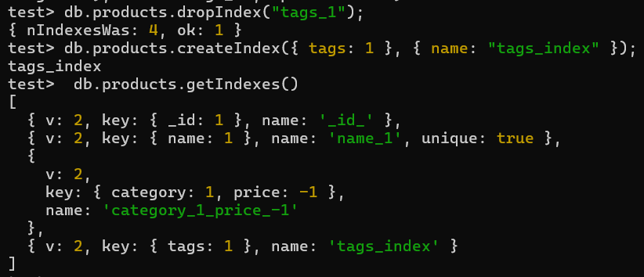

After executing `db.products.dropIndex("tags_1")`, the existing `tags_1` index was successfully dropped, as indicated by the response `{ nIndexesWas: 4, ok: 1 }`. Subsequently, running `db.products.createIndex({ tags: 1 }, { name: "tags_index" })` created a new index on the `tags` field in ascending order (`1`) with the specified name `tags_index`. When `db.products.getIndexes()` is called, it shows the list of indexes on the `products` collection, including the default `_id` index, a unique index on the `name` field (`name_1`), the compound index on `category` and `price` (`category_1_price_-1`), and the newly created `tags_index` on the `tags` field. This setup allows efficient querying and indexing of the `tags` field, facilitating fast retrieval of documents based on the array elements in the `tags` field.